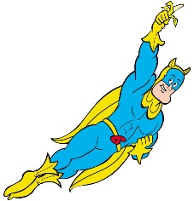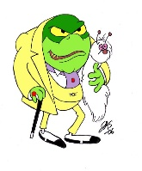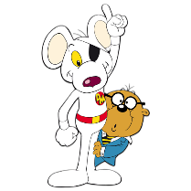

Maths

During this term both year groups will be focussing upon aspects of the following Maths themes in accordance with the year appropriate curriculum

* Number properties – place value, positioning and ordering number.
* Fractions – decimals and percentages (yr 5) and problem solving
* Geometry – shape and angles, and co-ordinates
* Calculation – mental

Strategies.

Kites Class – Spring Term Two 2017/18

Heroes and Villains.

R.E.

Salvation – Why do Christians call the day Jesus died, ‘Good Friday’?

Children will be thinking and learning about:

Their own joy and sadness

How Mary must have felt about the event of Easter

How Christians celebrate Easter

The relevance of the three different crosses – palm, crucifix and cross

The own response toward Easter events

SCIENCE

Our Science topic this term is a continuation of **Forces.** Children will examine;

Movement performance on different surfaces and friction

The concept of gravity

Air and water resistance

Levers/pulleys/gears and the change effect of force.

ENGLISH

During this term both year groups will be focussing upon aspects of grammar, spelling, reading and writing in accordance with the year appropriate curriculum.

Children will also explore: Writing to Inform, where they will have the opportunity to:

Write letters of persuasion

Write advertisements

Write recounts

Write news reports

The English focus will be on the adventures of superheroes.

FRENCH

We shall use this term to extend the children’s learning of the language whilst consolidating previous learning.

Children, this term, will cover school and hobbies including the phrases: J’aime … Je n’aime pas …, Je joue… and J’etudie…

Within these studies, children will get the opportunity to improve written and spoken French along with the improving of their understanding of read and heard French.

For additional information on the curriculum - https://www.gov.uk/government/uploads/system/uploads/attachment_data/file/425601/PRIMARY_national_curriculum.pdf

HISTORY

Our History topic for this term is: **THE ANCIENT GREEKS**. During this term the children will be taught about:

Important events in Ancient Greece.

The establishing of Ancient Greek civilisation and its impact worldwide.

Religious beliefs of the ancient Greeks.

Ancient Greeks arts and education.

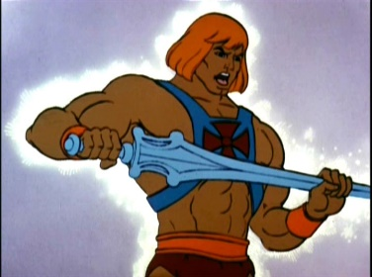

DESIGN TECHNOLOGY / ART

We will, in our science topic, be exploring forces and the children will be looking at, in DT, designing moving vehicles (in miniature form) which will link with the concept of force and friction. Children will be expected to examine similar products, plan, make and evaluate. They will be expected to choose appropriate materials and tools in order to complete the task.

In Art, the children will look at the skill of drawing as their focus. During this term the children will work at improving and developing their drawing skills through the experience of using different media and refining their observational skills.

MUSIC

The children will follow a programme of music designed to cover the objectives set out in the National Curriculum.

Children will be given the opportunity to play a range of instruments, and learn about musical notation and corresponding vocabulary. They will also be given the opportunity to perform and evaluate others’ performances as well as experience music of different genres and periods in history. Children will also be given the opportunities to respond to music of different genres.

P.S.H.E.

Our focus this term will continue with the theme - ‘It’s good to be me’.

We will be exploring how we can celebrate our differences and how important it is to feel good about ourselves. We will work on improving self-confidence, both as a class and as individuals, in order to make us get the most out of our learning as we can (without the obstacle of fear of getting things wrong).

INFORMATION TECHNOLOGY

We will spend time understanding the importance of safe use of the internet. The children will also learn how to keep themselves safe on the World Wide Web.

We will be furthering our education of programming – looking at the use of sequences and repetition in the creation of algorithms.

Children will also be encouraged to use the Internet as a research tool in a safe and accurate way.

GEOGRAPHY

Our focus for this term is to study – human natural resources.

We will be looking at:

* food from other countries.
* settlements.
* trade with other countries.
* natural resources.

P.E.

Our indoor P.E. focus will be on **Gym**. We will be using all apparatus to create individual, and small group routines on the theme of Heroes and Villains. This will develop, in the children, the skills of: strength, balance and poise. The children will be expected to plan, rehearse, perform and evaluate performances, making improvements as required.

Outdoor P.E. will focus upon team sports and will involve the learning and development of skills as well as giving the children the opportunity to take part in matches within school and against other schools. The children will participate in **Tag Rugby** – lots of exercise, lots of fun and lots of mud!