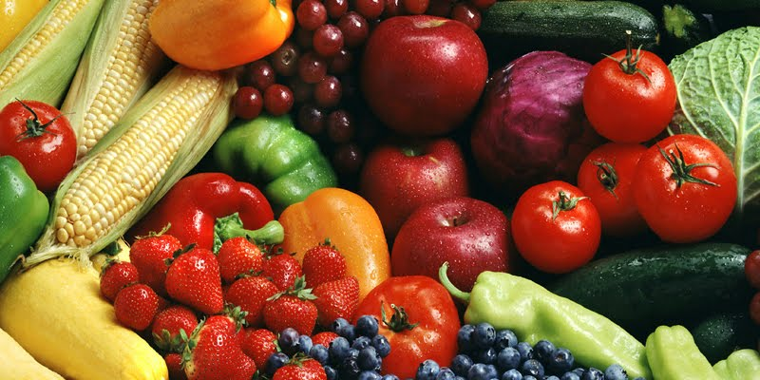

FRENCH

We shall use the first term as a refresher and consolidating term of previous learning to cover:

Days and months, numbers to 30, the alphabet, general polite conversation, and sharing personal details.

Within these studies, children will get the opportunity to improve written and spoken French along with the improving of their understanding of read and heard French.

ENGLISH

During this term both year groups will be focussing upon aspects of grammar, spelling, reading and writing in accordance with the year appropriate curriculum:

Writing: Writing to inform.

* Instructions – games – P.E. link
* Instructions – recipes – D.T. link
* Instructions – algorithms – I.T. link
* Instructions – experiments – science link
* Recount writing

Writing to persuade.

* Holiday brochure

For additional information on the curriculum - https://www.gov.uk/government/uploads/system/uploads/attachment_data/file/425601/PRIMARY_national_curriculum.pdf

Maths

During this term both year groups will be focussing upon aspects of the following Maths themes in accordance with the year appropriate curriculum

* Number properties – place value, positioning and ordering number, roman numerals.
* Calculation – four calculations mental and written strategies, problem solving, reasoning involving calculation and number.

HISTORY

Our History topic for this term is: **THE ROMANS**. During this term the children will be taught about:

Roman rule – the invasion of Britain, battles, Boudicca and Hadrian’s Wall.

Roman army – soldiers and weapons

Roman Law

Roman settlement – the Roman ‘take-over’, place names and civilisation.

R.E.

We are following the Wiltshire R.E. syllabus and this term we shall be focussing on ‘Creation and Fall’ with a Christian focus.

We shall be using extracts from Genesis to explore the Creation Story and the story of Adam and Eve.

The children will be looking at the meanings for Christians behind these stories.

The children will identify the wonders of the world and the concept of making mistakes and forgiveness.

Focus question – What do Christians learn from the Creation Story?

SCIENCE

Our Science topic this term is – **PLANTS**.

Children will examine; the requirements of living things (plants) in order to survive, the life-cycle of flowering plants with particular reference to seed dispersal, pollination and seed formation, and the purpose of different parts of a plant. They will also learn about water transportation in plants, and the classification of plants as living things alongside other living organisms and the usefulness and purpose of classification.

Kites Class – Autumn Term One 2017/18

Food, glorious food.



P.E.

Our indoor P.E. focus will be on gym. We will be using all apparatus to create individual, and small group routines on the theme of travelling. This will include the development of skills in: strength, balance and poise. The children will be expected to plan, rehearse, perform and evaluate performances, making improvements as required.

Outdoor P.E. will focus upon team sports and will involve the learning and development of skills as well as giving the children the opportunity to take part in matches within school and against other schools.

MUSIC

The children will follow a programme of music designed to cover the objectives set out in the National Curriculum.

Children will be given the opportunity to play a range of instruments, and learn about musical notation and corresponding vocabulary. They will also be given the opportunity to perform and evaluate others performances as well as experience music of different genres and periods in history.

DESIGN TECHNOLOGY

We will, in our History topic, be looking at the construction of catapults and the children will be designing, making and evaluating the making of their own catapults – redesigning to improve performance.

We will also create recipes and make pizzas – focussing on the ‘healthy eating’ aspect of cooking.

INFORMATION TECHNOLOGY

We will spend time understanding the importance of safe use of the internet. The children will also learn how to keep themselves safe on the World Wide Web.

We will be furthering our education of programming – looking at the use of sequences and repetition in the creation of algorithms.

GEOGRAPHY

Our focus for this term is to study – human natural resources.

We will be looking at:

* food from other countries.
* settlements.
* trade with other countries.
* natural resources.

P.S.H.E.

Our focus this term will be ‘Looking After Ourselves.’

To link with our theme of food, the children will be looking at healthy eating, but will also link this with looking after ourselves – good and bad medicines, hazards of smoking and alcohol, and the benefits of good personal hygiene.