Term 2 planning (2017-2018) Skylarks mixed Y3/Y4 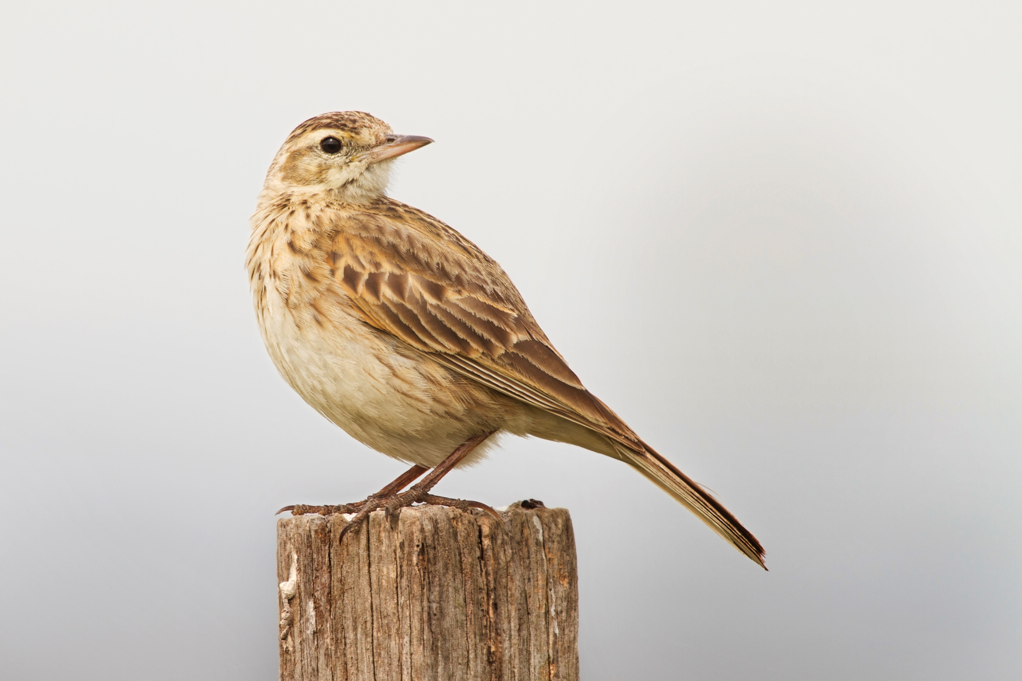
Mathematics
Addition and subtraction – Revise strategies (pairs of numbers to 10, pairs of numbers to 100, near doubles etc) to assess efficiency of calculations; check subtractions by quick addition (and vice versa); revise column subtraction and decomposition.
Time, bar charts, pictograms – Read the time to the nearest 5 minutes; use analogue clocks (with Roman numerals) and digital; solve time problems using seconds, minutes and hours; present and interpret pictograms.
Multiplication and division – Use grid method to multiply TU x U. Use chunking to divide by 3, 4, 6 with no remainders. Use chunking to divide by 3, 4, 6 and 8 with no remainders.
Division and fractions - Divide two-digit numbers by single-digit numbers using written layout for chunking; check division with multiplication; count in 1/4s, 1/3s and 1/10s saying the equivalent fractions, e.g. 1 ½ not 1²/4; understand the link between finding fractions of amounts and division.
Place value and decimals – Look at how dividing and multiplying by 10 moves the decimal place; order numbers with one decimal place; round tenths to nearest moves the decimal place; order numbers with one decimal place; round tenths to nearest whole.
Mental and written addition and subtraction – Use compact addition; use expanded decomposition and then compact decomposition; remember to check answers and choose most efficient methods of calculation.

English
Spoken language – Speak audibly and fluently, participate in presentations and performances, participate in collaborative conversations. We will have focused ‘Spoken Language’ sessions this term.
Reading – Guided reading in groups will focus on particular texts; authors’ intentions, language, story structure and characterisation.
Writing – Information texts, dictionaries, glossaries, labelled diagrams, Diwali poetry, stories from other cultures and cartoons.
Handwriting – Continue to practise our joined-up letter formation with a particular focus on ascenders and descenders.
Spelling, Punctuation and Grammar
Look at rarer GPCs, homophones and strategies for learning how to spell words; the prefixes ‘mis’ and ‘re’; use of our personal spelling books; proof reading and words ending in ‘gue’ and ‘que’ (Y3)
Revise possessive apostrophes; strategies for learning words; homophones; proof reading; prefixes ‘in’, ‘il’, ‘im’, ‘ir’; less common graphemes; adding suffixes ‘ing’, ‘er’, ‘en’ and ‘ed’ to words of more than one syllable (Y4).

Both year groups will also work on word classes, main and subordinate clauses and phrases.

As we get closer to Christmas we will be reading ‘A Christmas Carol’ by Charles Dickens but we will begin the term with two novels by Elen Caldecott (The Marsh Road Mysteries).
History - The Roman Empire (continued)
Invasion of Britain; British resistance and the Romanisation of Britain.


Celebrations


RE (Hinduism - Diwali)
Learn about the story of Rama and Sita and the fight between Good and Evil. Find out about Divali celebrations and the part children take in the celebrations. Find out about the strong sense of belonging to a community and family.

Science (to be continued)
Explore the role flowers play in the life cycle of flowering plants, name the different parts of a flowering plant, ask questions, make comparisons, make careful observations, devise and carry out simple investigations, gather and present data, use results to draw simple conclusions
PSHE (Out and about)
What makes a good listener, a good turn taker and a good speaker? How do we ‘see things from another point of view?” Discuss ‘personal safety’ in a number of different situations such as crossing the road, watching fireworks and fire.

Art
Follow up our half term homework and draw in the style of Jean-Francois Millet. Use this style to create a picture of Oliver Twist or Pip (from ‘Great Expectations’).
Look at the work of Marianne North. Notice the incredible detail in the pictures. Can we produce this level of accuracy when drawing/painting flowers?

D&T (Cooking and Nutrition)
Prepare some simple savoury dishes based around Italian food such as pasta and pizza.

ICT
Continue to access information for other curriculum areas using online tools; begin to become more selective; revise programming floor robots (algorithms); understand how to decompose sequences ready for programming; explore Scratch


PE
Games – Net and wall games; knowing positions and working as a team
Gym – Use skills in different ways and link them to make action and sequences of movement; perform a range of actions with consistency, fluency and clarity of movement; describe how our bodies feel when exercising; develop balance; describe and evaluate the effectiveness and quality of a performance; learn how to recognise own success.

French
Count to 20.
Revise simple greetings.
Begin to answer simple questions.
Learn some classroom vocabulary.
Begin to read some of the above
Geography (human/land use)
Compare farming in the UK with farming close to the Equator (banana growing).
Look at natural resources around the World – focus on water. How do people grown crops in areas where there is little rainfall?
Celebrations

Music (descriptive sounds)
Look at the tradition of telling stories with music and movement focussing on hand gestures (hasthas) used in Indian story telling.
Look at how music can be used to represent animal movements.
Add music to an animal narration and mime.

