Term 3 planning (2017-2018) Skylarks mixed Y3/Y4 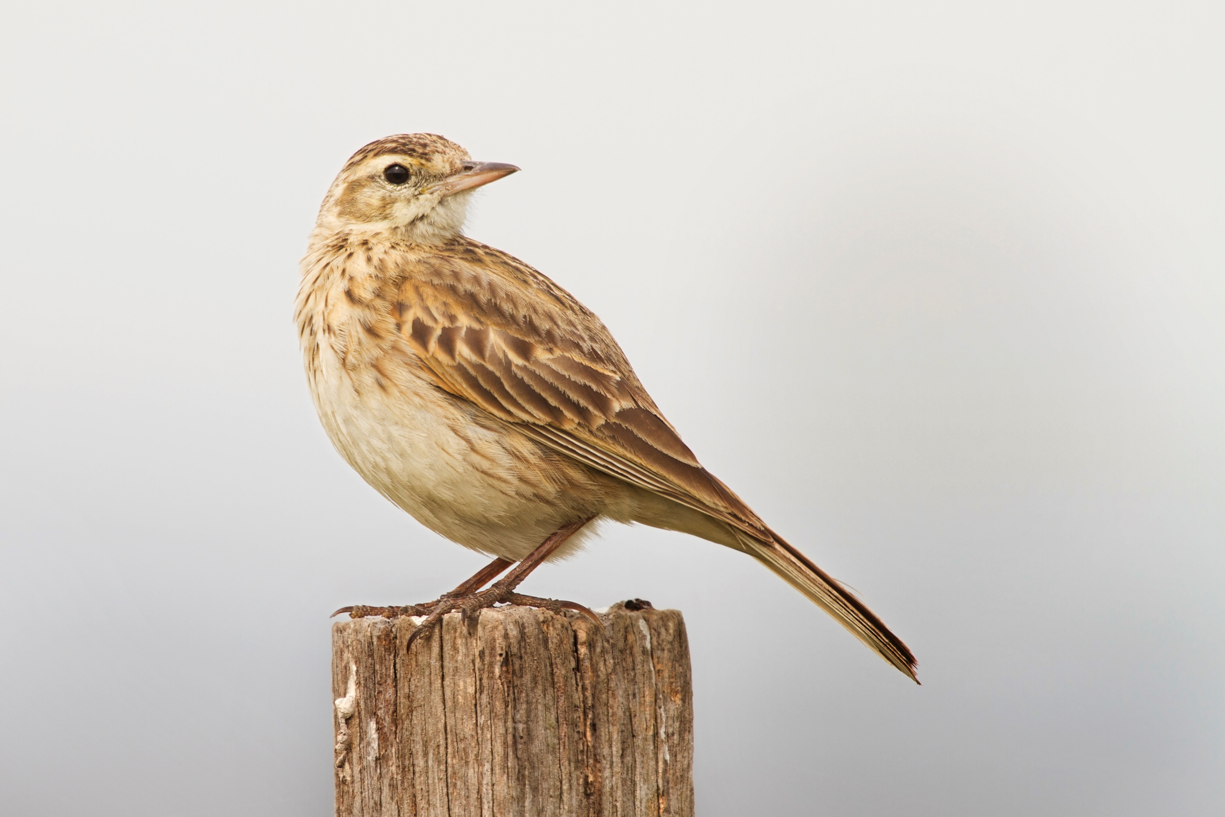
Mathematics
Division and fractions - Divide two-digit numbers by single-digit numbers using written layout for chunking; check division with multiplication; count in 1/4s, 1/3s and 1/10s saying the equivalent fractions, e.g. 1 ½ not 1²/4; understand the link between finding fractions of amounts and division
Place value and decimals – Look at how dividing and multiplying by 10 moves the decimal place; order numbers with one decimal place; round tenths to nearest moves the decimal place; order numbers with one decimal place; round tenths to nearest whole
Mental and written addition and subtraction – Use compact addition; use expanded decomposition and then compact decomposition; remember to check answers and choose most efficient methods of calculation
Measures and data – Measure and convert in m, cm and mm; measure and convert kg and g; make sensible estimations; measure objects and record in tables; represent and interpret data in bar charts
Fractions – Count in 1/2s and 1/4s; understand concept of fractions; begin to understand eighths; identify equivalent fractions; reduce fractions to their simplest form; link decimals and fractions

English
Spoken language – Speak audibly and fluently, participate in presentations and performances, participate in collaborative conversations
Reading – Guided reading in groups will focus on particular texts; authors’ intentions, language, story structure and characterisation.
Writing – Information texts, dictionaries, glossaries, labelled diagrams, pirate poetry, biography, story writing and characterisation
Handwriting – Continue to practise our joined-up letter formation with a particular focus on ascenders and descenders.
Spelling, Punctuation and Grammar
Words ending in ‘-gue’ and ‘-que’, revise suffixes ‘-ness’, ‘-ful’, ‘-ly’ and ‘-less’, learn prefixes ‘sub-‘ and ‘tele-‘, revise contractions, words with ‘sh’ sound spelt ‘ch’(Y3)

Prefixes ‘in’, ‘il’, ‘im’, ‘ir’; less common graphemes; adding suffixes ‘ing’, ‘er’, ‘en’ and ‘ed’ to words of more than one syllable, words ending in ‘-ture’, revision of homophones, possessive apostrophe for plurals (Y4).

Both year groups will also work on word classes, main and subordinate clauses, phrases, determiners, prepositions and fronted adverbials

We will be reading a novel by Elen Caldecott (The Marsh Road Mysteries) and ‘Treasure Island’ by Robert Louis Stevenson
History - The Roman Empire (continued)
Invasion of Britain; British resistance and the Romanisation of Britain.

Treasure around the World - pirates


RE (Christianity – People of God)
Learn to use a Bible looking for books, chapters and verses
Read the story of Noah and consider the pact or covenant made between Noah and God
What does this tell you about the relationship between the two?
What rules or agreements do we have to follow?
Find out about the Christian marriage ceremony and the promises involved. What happens when people don’t keep their promises?
Make links with the story of Abraham
Can we be people of God?

Science (humans)
Describe the changes as humans age
Describe the simple functions of the basic parts of the digestive system in humans
Identify the different types of teeth in humans and their simple functions
Recognise the impact of diet, exercise, drugs and lifestyle on the way our bodies function
Describe ways in which nutrients and water are transported within animals including humans
PSHE (Looking forward)
Think about begin responsible for own learning and behaviour
Find out about trust, wants, needs, setting goals, rights and responsibilities
What is charity and Fairtrade?

Art
Look at the art of mosaic making
Find out about the French street artist ‘Invader’
Look at some famous mosaics and how Roman mosaics can tell us a lot about Roman life

ICT
Learn a lengthy, complex sequence by decomposing it
Create own sequence by recording it and preparing it for others to try out
Debug as necessary
Learn to ticker with ‘Scratch’
D&T (Cooking and Nutrition)
Prepare some simple savoury dishes based around Italian food such as pasta and pizza.

Treasure around the World –
Pirates

Geography (human/land use/resources)
Look at banana, coffee and rice growing
Find out about Fairtrade
Look at natural resources around the World – focus on coal and gas
Begin to explore renewable energy

French
Revise counting to 20 following simple instructions in French
Revise simple greetings, again with simple French instructions
Learn some French counting songs
Learn colours, names of fruit and some food items
Learns days of the week

PE
Dance – Street dance based on ‘tutting’. Create and perform poses and movements in time to the beat of the music which communicate character and narrative
Gym – Use gymnastics positions learnt last term and incorporate them into jumps from and onto PE equipment such as ‘A’ frames, benches, mats and ladders

Music (exploring rhythmic patterns)
Copy and create rhythmic patterns using body, voice and tuned/untuned percussion
Work with a partner and a group creating rhythmic patterns
Begin to record these patterns as a musical score

