**EXPLORERS**

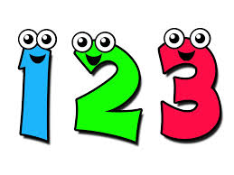

**Maths**

In Maths the children will be focusing on telling the time on analogue and digital clocks. They will also practise word problems and learn new strategies for mental maths.

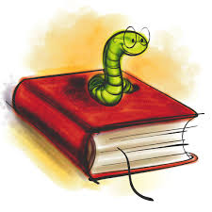

**English**

This term Skylarks will be writing their own comic strips and exploring different styles of persuasive writing including letters and advertisements. We also continue a focus on grammatical skills.



**French**

In French the children will learn how to introduce themselves and greet others through conversational French.

…



**RE**

Our focus this term will be The Easter Story with particular attention on ‘The Last Supper’.



**Art & Design Technology**

In Art & Design Skylarks will design and make boxes for an action figure.

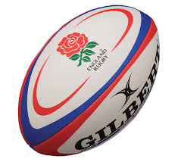

**PE**

The children will learn orienteering skills and on Thursdays Mr Smith will teach Tag Rugby.



**History**

In History the children will learn about the famous explorer Scott of the Antarctic.