**Treasure around the World**

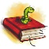

English: In English our main focus in Term 3 will be on listening to and writing Greek Fables and Myths. The children will learn about and write Aesop’s fables. They will then explore Ancient Greek myths and use their knowledge to inspire them to write their own myths in an extended writing task.

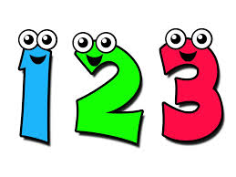

Maths: Hawks will focus on number work including long division,, decimals and percentages. They will then learn basic algebra and ratio and proportion.



**Religious Education:** Our focus this term will be on Sikhism and its beliefs and moral values. The children will also have the opportunity to visit a local Gurdwara; a Sikh temple.

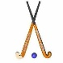

PE: In PE Hawks will have two sessions of hockey a week; on Wednesday with Mr Smith and on Friday with Mrs Wigglesworth

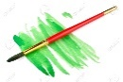

Art & Design Technology: We will be designing and making Greek style pots from clay; making Greek masks and designing mosaics taking their inspiration once more from Ancient Greece.

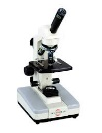In Science Hawks will explore ‘Humans’. The children will explore the heart, nutrients and the circulatory system.