**Up in the Air**

This term the children in year 6 will prepare for and sit the SATs tests in Mathematics, Grammar, Spelling and Punctuation and Reading. The tests begin in week 5:

The timetable is as follows:

Monday 14th May: English, grammar, spelling and punctuation papers 1 & 2

Tuesday 15th May: English Reading

Wednesday 16th May: Maths paper 1 (Arithmetic) & paper 2 (Reasoning)

Thursday 17th May: Maths paper 3 (Reasoning)

___________________________

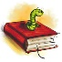

English: In English our main focus in Term 5 will be writing letters to a supermarket to persuade them to reduce the amount of plastic packaging in their stores. The children will also write ghost stories based on the short film ‘Alma’. The Civil Rights activist, Rosa Parks, will feature as a subject for biographies and diaries.

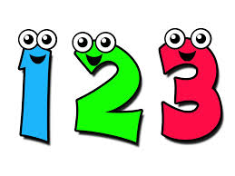

Maths: Hawks will focus largely on revision for the SATs Arithmetic and Reasoning papers. They will have lots of opportunity to practise SATs style and past question papers.



**Religious Education:** Our focus this term will be the ’Kingdom of God’. The children will explore how Christians put their beliefs into practice in different ways in their service to their communities.

[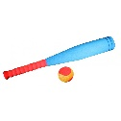](http://www.google.co.uk/url?sa=i&rct=j&q=&esrc=s&source=images&cd=&cad=rja&uact=8&ved=2ahUKEwievZnNk9HaAhWI7RQKHTFgDpkQjRx6BAgAEAU&url=http://www.edventure.co.uk/sports-c15/safe-rounders-bat-ball-p97&psig=AOvVaw16xLs8Wr4t_RVkK5xwLIcP&ust=1524598864167704)

PE: In PE Hawks will have a session of Athletics with Mr Smith every Wednesday. On Friday the children will be with Mrs Wigglesworth for Rounders. The children must have their PE kits in school for these days.

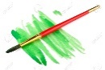

Art & Design Technology: We will be designing and making mosaic tiles at the start of the term and in the final week there will be a big focus on art and science project-based activities.

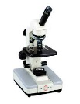In Science Hawks will continue to explore ‘Humans’ at the start of the term, looking at the circulatory system and organs and in the final week our focus will be on exploring Newton and Forces.