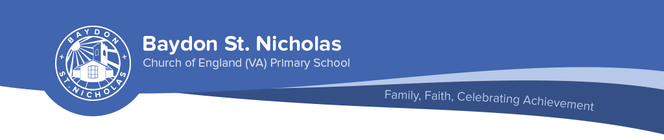

The children, staff and governors of

Baydon St Nicholas (VA) C. of E. Primary School

invite you to apply!

Baydon St Nicholas VA C of E Primary School are looking for a lead teaching professional excited by the challenge of engaging pupils and transforming their potential into achievement.

Are you the person for us?
If you are an inspiring and creative person willing to bring fresh and interesting ideas and experience to a small school with a forward thinking and supportive Governing Body, pupils with enthusiasm and talent and parents with high expectations all with a wish to move on in our journey from ‘good’ to ‘outstanding’ then please come and meet us and our children!

The closing date for the application is Thursday 3rd March. Candidates shortlisted for this post will be contacted by telephone to be invited to attend for interview on Friday 18th March. The successful candidate will take up post at the beginning of the Autumn term September 2016.

You are warmly invited to download or request our information pack and visit the school. Please call Shireen Waterer (School Administrator) on 01672 540554 or email: admin@baydon-st-nicholas.wilts.sch.uk to arrange a time.

If you share our vision, we would be delighted to receive your application and to learn what you would be able to offer our school community.

We are committed to safeguarding and promoting the welfare of our pupils and expect all staff and volunteers to share this commitment. All staff appointments and regular volunteers are CRB checked.

